LAB 4

NAME: KAUSHAL KHATIWADA

ROLL_NO: 13

1. Create tables Teacher (Id INT PRIMARY KEY, Tname VARCHAR(20)) and Student (id INT PRIMARY KEY, Sname VARCHAR(20));

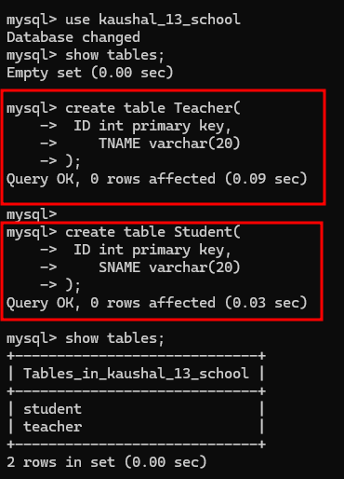

1. Insert values like {(“1,”Ram”), (2,”Hari”), (3,”Sita”)} in Teacher and {(“2,”Hari”), (3,”Sita”), (4,”Gita”)} in Student.

1. Write query to find Union of Teacher and Student.

**UNION** combines the result of two select operation.

1. Write query to find Intersection of Teacher and Student.

**INTERSECT** return only common rows from select operation

1. Write query to find intersection of names Teacher and Student using Distinct and Inner Join

**DISTINCT** only returns the distinct or different values.

**INNER JOIN** selects the record that has matching value in both tables.

1. Write query to find intersection of names Teacher and Student using IN and Sub query

1. Write query to find Teacher MINUS Student using Left Join

Returns only those rows which are unique in only first table.

1. Find the number of offices in the Office table from the COMPANY Database in Lab-1 using COUNT function.

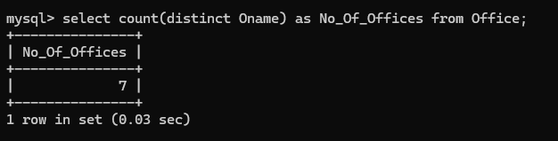

1. Write a query to count the distinct names of Employees.

1. Write a query to find sum of salary of Employees.

1. Write a query to find average of salary of Employees.

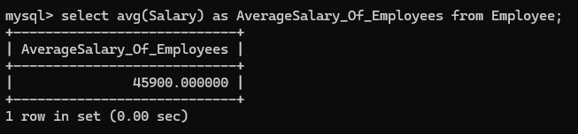

1. Write a query to find Maximum PF Amount from the PF Table.

1. Write a query to find Minimum PF Amount from the PF Table.

